**TEAMDUTY Web-application**

Software Design Document

**By**

Mr. Manuchet Manoi 542115049

Mr. Saknarong Noipaksa 542115061

Department of Software Engineering

College of Arts, Media and Technology

Chiang Mai University

**Project Advisor**

______________________________________

**Aj. Jayakrit Hirisajja**

**Document History**

|  |  |  |  |  |  |  |  |
| --- | --- | --- | --- | --- | --- | --- | --- |
| **Document Name** | **Version** | **Status** | **Date** | **Viewable** | **Reviewer** | | **Responsible** |
| **Documents** | | | | | | | |
| TEAMDUTY - Web application – SDD v 0.1.docx | **Add Chapter 1**  - Objective  - Intended Audience and Reading Suggestions  - Project Scope | Draft | 01 May 2014 | MM,  SN,JH | | MM,  SN | MM,  SN |
| TEAMDUTY - Web application - SDD v 0.2.docx | **Add Chapter 2**  **Add Chapter 3** | Draft | 01 May 2014 | MM,  SN,JH | | MM,  SN | MM,  SN |
| TEAMDUTY - Web application - SDD v 0.3.docx | **Add Chapter 4**  - Class Diagram  - Class Diagram Description  - Sequence Diagram | Draft | 24 May 2014 | MM,  SN,JH | | MM,  SN | MM,  SN |
| TEAMDUTY - Web application - SDD v 0.4.docx | **Add Chapter 5**  - ER Diagram  - DB Design  **Add Chapter 6**  - User Interface Design | Draft | 16 June 2014 | MM,  SN,JH | | MM,  SN | MM,  SN |
| TEAMDUTY - Web application - SDD v 0.5.docx | **Adjust Chapter 4**  - Add more Class Diagram  - Add more Class Diagram Description  - Add more Sequence Diagram  **Adjust Chapter 5**  - Change ER Diagram  - Change DB Design  **Adjust Chapter 6**  - Adjust User Interface Design | Draft | 06 July 2014 | MM,  SN,JH | | MM,  SN | MM,  SN |
| TEAMDUTY - Web application - SDD v 1.0.docx | **Adjust Chapter 6**  - Adjust User Interface Design  **Adjust Chapter 5**  - Change ER Diagram  - Change DB Design | Draft | 21 July 2014 | MM,  SN,JH | | MM,  SN | MM,  SN |

**\*MM = Manuchet Manoi**

**\*SN = Saknarong Noipaksa**

**\*JH = Jayakrit Hirisajja**

**Table of Contents**

Chapter One | Introduction 4

1.1 Objective 4

1.2 Intended Audience and Reading Suggestions 4

1.3 Project Scope 4

Chapter Two | System Overview 5

Chapter Three | Detail Design 6

3.1 Class Diagram 6

3.1.1 Controller Package Class 6

3.1.2 Repository Package Class 7

4.1.3 Model Class 8

3.2 Class Diagram Description 10

3.2.1 Controller Class Description 10

3.2.2 Repository Class Description 16

3.2.3 Model Class Description 24

3.3 Sequence Diagram 29

*service request customer* 29

*freelancer supply* 39

Chapter Four | Data Architecture 45

4.1 ER Diagram 45

4.2 DB Design 46

Chapter Five | User Interface Design 49

# Chapter One | Introduction

## Objective

The Objective of this (SDD) Software Design Document is establish design for TEAMDUTY Web application and show all of program design and data of TEAMDUTY Web application. And this Software Design Document is guidelines for develop software correctly .This Software Design Document is contains with a complete description of the design system for developer can develop TEAMDUTY Web application.

## Intended Audience and Reading Suggestions

This Software Design Document documentation is intended to be used for anyone that relate with TEAMDUTY Web application. The documentation will benefit to those who develop the system and those who use the system followed:

**Development team**

* The Software Design Document can be present architecture within software product
* The Software Design Document can be coordinate a development team under a single vision.
* The Software Design Document help development team know roughly semblance of program
* The Software Design Document can be help development team know information within program before develop

**User**

* The Software Design Document can be help User know roughly semblance of program
* The Software Design Document can be help User to know flow event to use software product

## Project Scope

The scope of this software design document is strategies to establish the system that:

* The Software System is Web-application.
* The Software System provide only software side.
* The Software System divide to two main part of user that is software human resource, and software job auction project.
* Show requirement and detail of Software system

TEAMDUTY – web application is a website application. This will provide a system to manage about software freelance finding job software human resource.

# Chapter Two | System Overview

TEAMDUTY Web application in this first progress is consisting of two past of feature that is Account management system and Service request customer management system

First, Account management system is past of system to provide both of Freelance Supply and Service request customer to Register ,ConfirmRegister to be member ,Login to using system and adjust about their profile to show to other user within system.

Second, Service Request customer management system is past of system to provide Service Request Customer to post project, view other project within system and view list of freelancer that come to bid project and show detail in each bidding as Freelancer that come to bidding, bid detail and budget to use in each bid.

That is all for phase 1 .we will separated Software Design Document into 3 phase follow that

|  |  |
| --- | --- |
| **Submit on-** | **Software Design and Architectures of-** |
| May | Feature 1 # Account Management System  Feature 2 # Service request customer management system. |
| July | Feature 3 # Search system  Feature 4 # Software-freelance supply management system  Feature 5 # Communication system |
| September | Feature 6 # Verification system  Feature 7 # Admistrator Management system |

# Chapter Three | Detail Design

## 3.1 Class Diagram

### 3.1.1 Controller Package Class

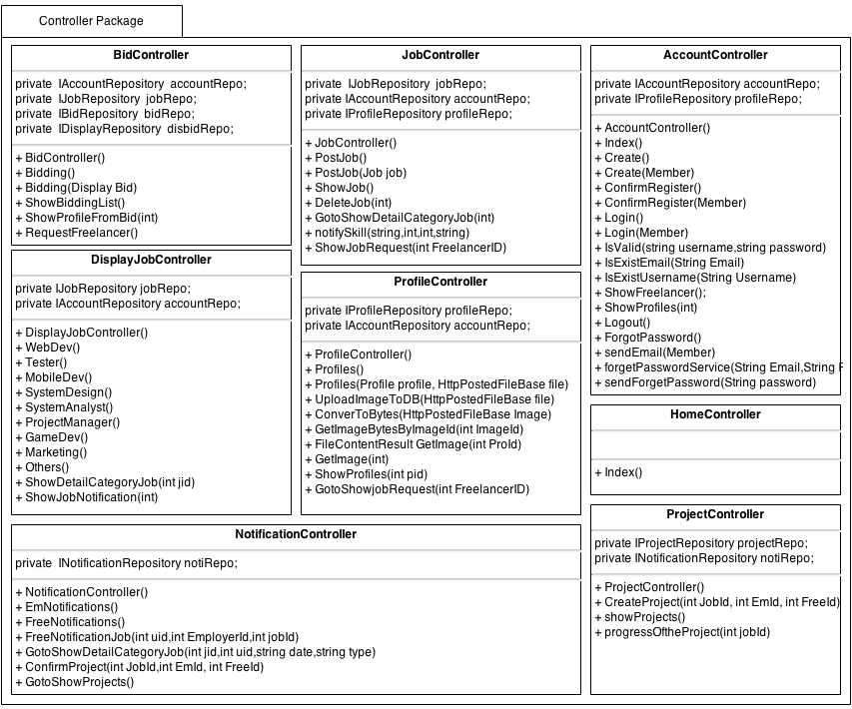This class diagram will be show Method and attribute in each class only progress 1 + progress 2

### 3.1.2 Repository Package Class

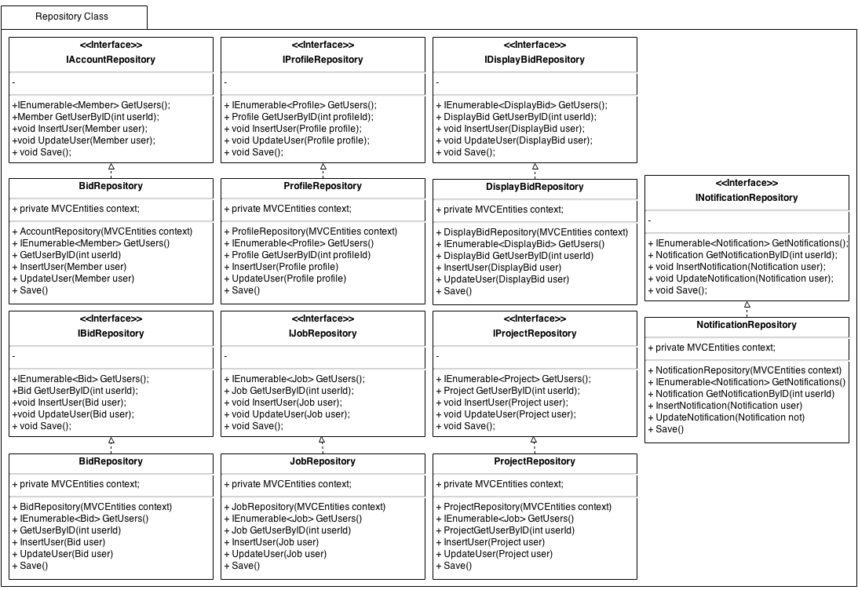

### C:\Users\User\Desktop\Senior project\pic\Class Diagram\Model.png4.1.3 Model Class

TEAMDUTY – ClassDiagram Phase1

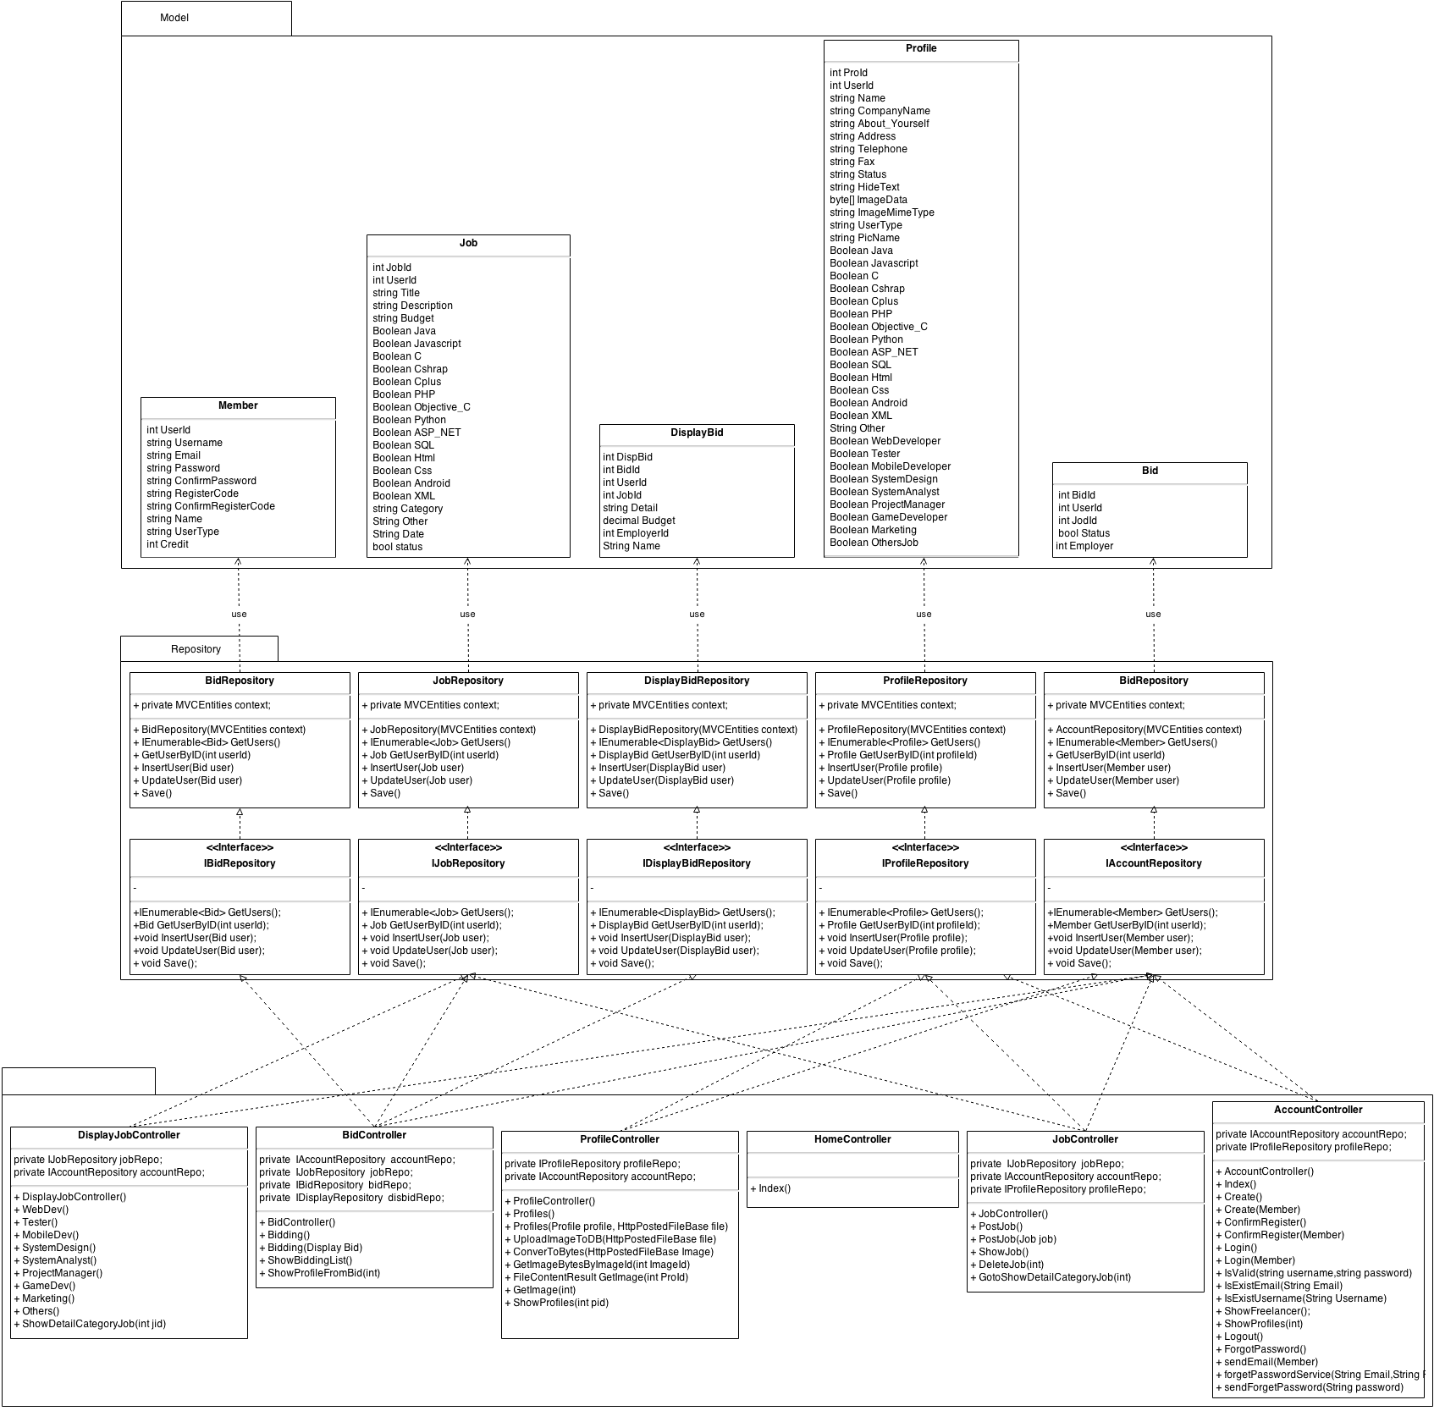

## 3.2 Class Diagram Description

This class diagram Description will be show Method and attribute in each class only progress1

### 3.2.1 Controller Class Description

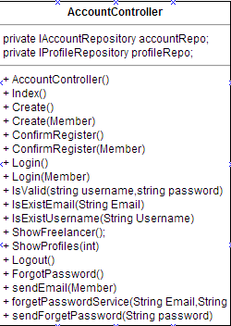

**Property**

|  |  |  |  |
| --- | --- | --- | --- |
| **ID** | **Name** | **Description** | **Remark** |
| 1 | accountRepo | Variable that build to call IAccountRepository Object in this class | Type: IAccountRepository object |
| 2 | profileRepo | Variable that build to call IProfileRepository Object in this class | Type: IProfileRepository object |

**Methods**

|  |  |  |  |
| --- | --- | --- | --- |
| **ID** | **Name** | **Description** | **Remark** |
| 1 | Index() | The system call this method to show text list of User | returnType:View(user)  Parameter:- |
| 2 | AccountController() | The System use this method to call object from Repository | returnType:  Parameter: |
| 3 | Create(Member member) | The System use this method to insert member into database,identify type of user and send link to Email | returnType: RedirectToAction("Index", "Home");  Parameter: member |
| 4 | ConfirmRegister(Member member) | The System use this method to ConfirmRegister again  and insert other user information to register. | returnType: RedirectToAction("Index", "Home");  Parameter:member |
| 5 | Login(Member member) | The system use this method identify user to using web application | returnType: RedirectToAction("Index", "Home");  Parameter:member |
| 6 | IsValid(String username,String password) | The system use this method check username and password that log-in  found in database list or not. | returnType:bool  Parameter: String username, String password |
| 7 | IsExistEmail(String Email) | The system use this method check Email that Register Exist in database or not | returnType:bool  Parameter: String Email |
| 8 | IsExistUsername(String Username) | The system use this method check Username that Register Exist in database or not | returnType:bool  Parameter: String Username |
| 9 | ShowFreelancer() | The system call this method to show list of Freelancer in system | returnType: View(users);  Parameter: |
| 10 | ShowProfiles(int) | The system use this method o show profile of Freelnacer | returnType: RedirectToAction("ShowProfiles", "Profile", new { pid = id });  Parameter:- |
| 11 | forgetPassword() | The system use metjod to call forgetpassword view page | returnType:  Parameter:- |
| 12 | sendEmail() | The system use this method to send email to user. | returnType:  Parameter:- |
| 13 | forgetPasswordServoce(String Email,RegisterCode) | The system use this method to receive Email & RegisterCode and validate them | returnType:  Parameter: String Email,String RegisterCode |
| 14 | SendForgetPassword(String Password) | The system use this methed to send password to email that user forgot | returnType:  Parameter:- |
| 15 | Logout() | The system use this method to logout | returnType: RedirectToAction("index", "Home");  Parameter:- |

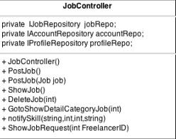

**Property**

|  |  |  |  |
| --- | --- | --- | --- |
| **ID** | **Name** | **Description** | **Remark** |
| 1 | jobRepo | Variable that build to call IJobRepository Object in this class | Type: IJobRepository object |
| 2 | accountRepo | Variable that build to call IAccountRepository Object in this class | Type: IAccountRepository object |
| 3 | profileRepo | Variable that build to call IPeofileRepository Object in this class | Type: IProfileRepository object |

**Methods**

|  |  |  |  |
| --- | --- | --- | --- |
| **ID** | **Name** | **Description** | **Remark** |
| 1 | JobController() | The System use this method to call object from Repository | returnType: -  Parameter: - |
| 2 | PostJob(Job job) | The system use method to insert job information  To database | returnType: View();  Parameter: Job Object |
| 3 | ShowJob() | The system use this method to Show list of job in  database | returnType: View(jobs);  Parameter:- |
| 4 | DeleteJob(int id) | The system use this method to delete job by use jobid | returnType: -  Parameter: int id |
| 5 | GotoShowDetailCategoryJob(int jid) | The system use this method to showjobDetail by use jobid | returnType: -  Parameter: int jid |
| 6 | NotifySkill | The system use this method to Validate skill and show Employerid ,jobid and Date | returnType: -  Parameter: int jid |
| 7 | showJobRequest (int FreelanceId) | The system use this method to ShowJobRequest by use FreelancerId | returnType: View(jobs)  Parameter: int FreelanceId |

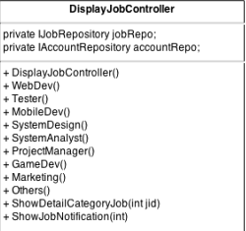

**Property**

|  |  |  |  |
| --- | --- | --- | --- |
| **ID** | **Name** | **Description** | **Remark** |
| 1 | jobRepo | Variable that build to call IJobRepository Object in this class | Type: IJobRepository object |
| 2 | accountRepo | Variable that build to call IAccountRepository Object in this class | Type: IAccountRepository object |

**Methods**

|  |  |  |  |
| --- | --- | --- | --- |
| **ID** | **Name** | **Description** | **Remark** |
| 1 | DisplayJobController() | The System use this method to call object from Repository | returnType: View("CategoryJob", jobs);  Parameter: |
| 2 | WebDev() | The system use this method to display job of WebDeveloper Page | returnType: View("CategoryJob", jobs);  Parameter: |
| 3 | Tester() | The system use this method to display job of  Tester Page | returnType: View("CategoryJob", jobs);  Parameter: |
| 4 | MobileDev() | The system use this method to display job of MobileDeveloper Page | returnType: View("CategoryJob", jobs);  Parameter: |
| 5 | SystemDesign() | The system use this method to display job of SystemDesign Page | returnType: View("CategoryJob", jobs);  Parameter: |
| 6 | SystemAnalyst() | The system use this method to display job of SystemAnalyst Page | returnType: View("CategoryJob", jobs);  Parameter: |
| 7 | ProjectManager() | The system use this method to display job of  Project manager Page | returnType: View("CategoryJob", jobs);  Parameter: |
| 8 | GameDev() | The system use this method to display job of GameDeveloper Page | returnType: View("CategoryJob", jobs);  Parameter: |
| 9 | Marketing() | The system use this method to display job of Software MarketingPage | returnType: View("CategoryJob", jobs);  Parameter: |
| 10 | Other() | The system use this method to display job of other software role job Page | returnType: View("CategoryJob", jobs);  Parameter: |
| 11 | ShowDetailCategoryJob(int jid) | The system use this method to display detail in each job of every software role job Page | returnType: PartialView("ShowDetailCategoryJob",JobModel);  Parameter:int jid |
| 12 | ShowJobNotification(int jid) | The system use this method to ShowJobNotification by using jid(Jobid) | returnType: View("ShowJobNotification", JobModel);  Parameter:int jid |

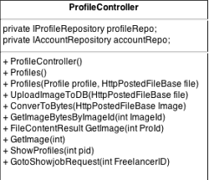

**Property**

|  |  |  |  |
| --- | --- | --- | --- |
| **ID** | **Name** | **Description** | **Remark** |
| 1 | profileRepo | Variable that build to call IProfileRepository Object in this class | Type: IProfileRepository object |
| 2 | accountRepo | Variable that build to call IAccountRepository Object in this class | Type: IAccountRepository object |

**Methods**

|  |  |  |  |
| --- | --- | --- | --- |
| **ID** | **Name** | **Description** | **Remark** |
| 1 | ProfileController() | The System use this method to call object from Repository | returnType:  Parameter: - |
| 2 | Profiles(Profile profile, HttpPostedFileBase file) | The System use this method to retrieve profile of user | returnType: RedirectToAction("Index", "Home");  Parameter:profile object, HttpPostedFileBase object |
| 3 | UploadImageToDB(HttpPostedFileBase file) | The System use this method to upload image to database | returnType:  Parameter: HttpPostedFileBase object |
| 4 | ConverToBytes(HttpPostedFileBase file) | The System use this method convert type of picture to byte | returnType: imageBytes  Parameter: HttpPostedFileBase Image |
| 5 | GetImageBytesByImageId(int ImageId) | The System use this method to find image in database list | returnType:  Parameter: int ImageId |
| 6 | FileContentResultGetImage(int Proid) | The System use this method to get image to profile id | returnType: new FileContentResult(byteArray, "image/jpeg");  Parameter: int Proid |
| 7 | ShowProfiles(int pid) | The System use this method to show profile | returnType: View(usersProfile)  Parameter: int pid |
| 8 | GotoShowjobRequest(int FreelanceId) | The System use this method to showjobRequest Page by using FrelancerId | returnType: RedirectToAction("showJobRequest", "Job", new { FreelanceId = FreelanceId });  Parameter: int FreelancerId |

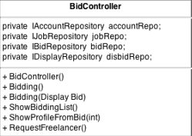

**Property**

|  |  |  |  |
| --- | --- | --- | --- |
| **ID** | **Name** | **Description** | **Remark** |
| 1 | accountRepo | Variable that build to call IAccountRepository Object in this class | Type: IAccountRepository object |
| 2 | jobRepo | Variable that build to call IJobRepository Object in this class | Type: IJobRepository object |
| 3 | bidRepo | Variable that build to call IBidRepository Object in this class | Type: IBidRepository object |
| 4 | disbidRepo | Variable that build to call IDisplayBidRepository Object in this class | Type: IDispalyBidRepository object |

**Methods**

|  |  |  |  |
| --- | --- | --- | --- |
| **ID** | **Name** | **Description** | **Remark** |
| 1 | ProfileController() | The System use this method to call object from Repository | returnType:  Parameter: |
| 2 | Bidding() | The system use this method to create View to Display | returnType: PartialView("Bidding");  Parameter: |
| 3 | Bidding(DisplayBid disbid) | The System use this method to add BidInformation to database | returnType: PartialView("Bidding");  Parameter: DisplayBid disbid |
| 4 | showBiddingList() | The System use this method to show bidder in project | returnType: PartialView("showBiddingList", bids);  Parameter: |
| 5 | ShowProfilesFromBid(int id) | The System use this method link to profile of bidder | returnType: RedirectToAction("ShowProfiles", "Profile", new { pid = id });  Parameter: int id |
| 6 | RequestFreelancer() | The system use this to request Freelancer | returnType: View("Bidding");  Parameter: |

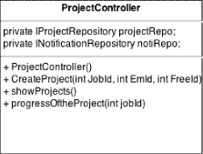

**Property**

|  |  |  |  |
| --- | --- | --- | --- |
| **ID** | **Name** | **Description** | **Remark** |
| 1 | projectRepo | Variable that build to call IProjectRepository Object in this class | Type: IProjectRepository object |
| 2 | notiRepo | Variable that build to call INotificationRepository Object in this class | Type: INotificationRepository object |

**Methods**

|  |  |  |  |
| --- | --- | --- | --- |
| **ID** | **Name** | **Description** | **Remark** |
| 1 | ProjectController() | The System use this method to call object from Repository | returnType:  Parameter: |
| 2 | CreateProject(int JobId,int EmId,int FreeId) | The system use this method to create ProjectManagement by using JobId | returnType:  Parameter: |
| 3 | ShowProject() | The System use this method to list of project that avaliable | returnType: View(Jobs);  Parameter: |
| 4 | progressOftheProject(int jobId) | The System use this method to show projectManagement Page | returnType: View(proJs);  Parameter: int jobId |

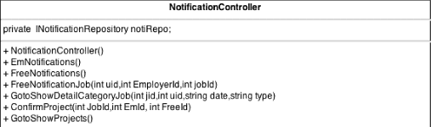

**Property**

|  |  |  |  |
| --- | --- | --- | --- |
| **ID** | **Name** | **Description** | **Remark** |
| 1 | notiRepo | Variable that build to call INotificationRepository Object in this class | Type: INotificationRepository object |

**Methods**

|  |  |  |  |
| --- | --- | --- | --- |
| **ID** | **Name** | **Description** | **Remark** |
| 1 | NotificationController() | The System use this method to call object from Repository | returnType:  Parameter: |
| 2 | EmNotifications() | The system use this method to showjob in Notification Page for Employer type | returnType: View(Notis);  Parameter: |
| 3 | FreeNotification() | The system use this method to showjob in Notification Page for Freelancer type | returnType: View(Notis);  Parameter: |
| 4 | FreeNotificationJob(int uid,int EmployerId,int jobid) | The System use this method to show request to do project from Employer | returnType:  Parameter: int uid,int EmployerId,int jobId |
| 5 | GotoShowDetailCategoryJob(int jid,int uid,string date,string type) | The System use this method to detail of job that show in Notification Page | returnType:  RedirectToAction("ShowJobNotification", "DisplayJob", new { jid = jid });  Parameter:  int jid,int uid,string date,string type |
| 6 | ConfirmProject(int JobId,int EmId, int FreeId) | The System use this method to confirm to do the project | returnType:  RedirectToAction("CreateProject", "Project");  Parameter:  int JobId,int EmId, int FreeId |
| 7 | GotoShowProjects() | The System use this method to confirm to do the project | returnType  RedirectToAction("showProjects", "Project");  Parameter: |

### 3.2.2 Repository Class Description

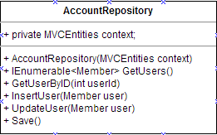

**Property**

|  |  |  |  |
| --- | --- | --- | --- |
| **ID** | **Name** | **Description** | **Remark** |
| 1 | context | Variable that build to call MVCEntities Object in this class | Type: MVCEntities object |

**Methods**

|  |  |  |  |
| --- | --- | --- | --- |
| **ID** | **Name** | **Description** | **Remark** |
| 1 | AccountRepository(MVCEntities context) | The System use this method to call object from Database context | returnType:  Parameter: |
| 2 | GetUsers() | The System use this method to get data from database | returnType: context.Members.ToList();  Parameter: |
| 3 | InsertUser(Member user) | The System use this method to find data from database | returnType:  Parameter: Member user |
| 4 | UpdateUser(Member user) | The System use this method to update data to database | returnType:  Parameter: Member user |
| 5 | Save() | The System use this method to save data to database | returnType:  Parameter: |
| 6 | GetUserByID(int userId) | The System use this method to find userId in database | returnType:  context.Members.Find(userId);  Parameter: int userId |

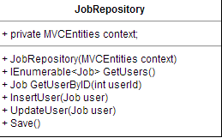

**Property**

|  |  |  |  |
| --- | --- | --- | --- |
| **ID** | **Name** | **Description** | **Remark** |
| 1 | context | Variable that build to call MVCEntities Object in this class | Type: MVCEntities object |

**Methods**

|  |  |  |  |
| --- | --- | --- | --- |
| **ID** | **Name** | **Description** | **Remark** |
| 1 | JobRepository(MVCEntities context) | The System use this method to call object from Database context | returnType:  Parameter: |
| 2 | GetUsers() | The System use this method to get data from database | returnType: context. Jobs.ToList();  Parameter: |
| 3 | InsertUser(Job user) | The System use this method to find data from database | returnType:  Parameter: Job user |
| 4 | UpdateUser(Job user) | The System use this method to update data to database | returnType:  Parameter: Job user |
| 5 | Save() | The System use this method to save data to database | returnType:  Parameter: |
| 6 | GetUserByID(int userId) | The System use this method to find userId in database | returnType:  context.Jobs.Find(userId);  Parameter: int userId |

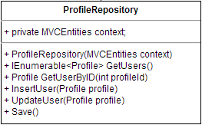

**Property**

|  |  |  |  |
| --- | --- | --- | --- |
| **ID** | **Name** | **Description** | **Remark** |
| 1 | context | Variable that build to call MVCEntities Object in this class | Type: MVCEntities object |

**Methods**

|  |  |  |  |
| --- | --- | --- | --- |
| **ID** | **Name** | **Description** | **Remark** |
| 1 | ProfileRepository(MVCEntities context) | The System use this method to call object from Database context | returnType:  Parameter: |
| 2 | GetUsers() | The System use this method to get data from database | returnType: context. Profiles.ToList();  Parameter: |
| 3 | InsertUser(Profile profile) | The System use this method to find data from database | returnType:  Parameter: Job user |
| 4 | UpdateUser(Profile profile) | The System use this method to update data to database | returnType:  Parameter: Job user |
| 5 | Save() | The System use this method to save data to database | returnType:  Parameter: |
| 6 | GetUserByID(int profileId) | The System use this method to find profileId in database | returnType:  context. Profiles.Find(profileId);  Parameter: int profileId |

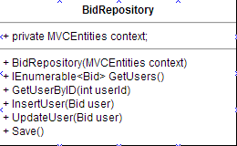

**Property**

|  |  |  |  |
| --- | --- | --- | --- |
| **ID** | **Name** | **Description** | **Remark** |
| 1 | context | Variable that build to call MVCEntities Object in this class | Type: MVCEntities object |

**Methods**

|  |  |  |  |
| --- | --- | --- | --- |
| **ID** | **Name** | **Description** | **Remark** |
| 1 | BidRepository(MVCEntities context) | The System use this method to call object from Database context | returnType:  Parameter: |
| 2 | GetUsers() | The System use this method to get data from database | returnType: context.Bids.ToList();  Parameter: |
| 3 | InsertUser(Bid user) | The System use this method to find data from database | returnType:  Parameter: Job user |
| 4 | UpdateUser(Bid user) | The System use this method to update data to database | returnType:  Parameter: Job user |
| 5 | Save() | The System use this method to save data to database | returnType:  Parameter: |
| 6 | GetUserByID(int userId) | The System use this method to find userId in database | returnType:  context.Bids.Find(userId); Parameter: int userId |

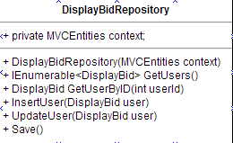 **Property**

|  |  |  |  |
| --- | --- | --- | --- |
| **ID** | **Name** | **Description** | **Remark** |
| 1 | context | Variable that build to call MVCEntities Object in this class | Type: MVCEntities object |

**Methods**

|  |  |  |  |
| --- | --- | --- | --- |
| **ID** | **Name** | **Description** | **Remark** |
| 1 | DisplayBidRepository(MVCEntities context) | The System use this method to call object from Database context | returnType:  Parameter: |
| 2 | GetUsers() | The System use this method to get data from database | returnType: return context.DisplayBids.ToList();  Parameter: |
| 3 | InsertUser(DisplayBid user) | The System use this method to find data from database | returnType:  Parameter: Job user |
| 4 | UpdateUser(DisplayBid user) | The System use this method to update data to database | returnType:  Parameter: DisplayBid user |
| 5 | Save() | The System use this method to save data to database | returnType:  Parameter: |
| 6 | GetUserByID(int userId) | The System use this method to find userId in database | returnType:  context.DisplayBids.Find(userId); Parameter: int userId |

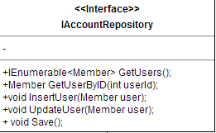

**Methods**

|  |  |  |  |
| --- | --- | --- | --- |
| **ID** | **Name** | **Description** | **Remark** |
| 1 | GetUsers() | The System use this method from Repository | returnType:  Parameter: |
| 2 | InsertUser(Member user) | The System use this method from Repository | returnType:  Parameter: Member user |
| 3 | UpdateUser(Member user) | The System use this method from Repository | returnType:  Parameter: Member user |
| 4 | Save() | The System use this method from Repository | returnType:  Parameter: |
| 5 | GetUserByID(int userId) | The System use this method from Repository | returnType:  Parameter: int userId |

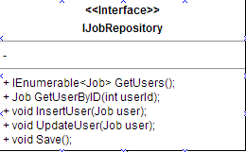

**Methods**

|  |  |  |  |
| --- | --- | --- | --- |
| **ID** | **Name** | **Description** | **Remark** |
| 1 | GetUsers() | The System use this method from Repository | returnType:  Parameter: |
| 2 | InsertUser(Job user) | The System use this method from Repository | returnType:  Parameter: Job user |
| 3 | UpdateUser(Job user) | The System use this method from Repository | returnType:  Parameter: Job user |
| 4 | Save() | The System use this method from Repository | returnType:  Parameter: |
| 5 | GetUserByID(int userId) | The System use this method from Repository | returnType:  Parameter: int userId |

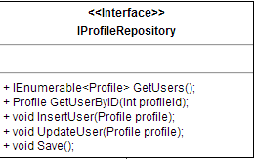

**Methods**

|  |  |  |  |
| --- | --- | --- | --- |
| **ID** | **Name** | **Description** | **Remark** |
| 1 | GetUsers() | The System use this method from Repository | returnType:  Parameter: |
| 2 | InsertUser(Profile profile) | The System use this method from Repository | returnType:  Parameter: Profile profile |
| 3 | UpdateUser(Profile profile) | The System use this method from Repository | returnType:  Parameter: Profile profile |
| 4 | Save() | The System use this method from Repository | returnType:  Parameter: |
| 5 | GetUserByID(int profileId) | The System use this method from Repository | returnType:  Parameter: int profileId |

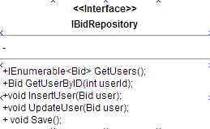

**Methods**

|  |  |  |  |
| --- | --- | --- | --- |
| **ID** | **Name** | **Description** | **Remark** |
| 1 | GetUsers() | The System use this method from Repository | returnType:  Parameter: |
| 2 | InsertUser(Bid user) | The System use this method from Repository | returnType:  Parameter: Bid user |
| 3 | UpdateUser(Bid user) | The System use this method from Repository | returnType:  Parameter: Bid user |
| 4 | Save() | The System use this method from Repository | returnType:  Parameter: |
| 5 | GetUserByID(int userId) | The System use this method from Repository | returnType:  Parameter: int userId |

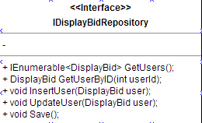 **Methods**

|  |  |  |  |
| --- | --- | --- | --- |
| **ID** | **Name** | **Description** | **Remark** |
| 1 | GetUsers() | The System use this method from Repository | returnType:  Parameter: |
| 2 | InsertUser(DisplayBid user) | The System use this method from Repository | returnType:  Parameter: DisplayBid user |
| 3 | UpdateUser(DisplayBid user) | The System use this method from Repository | returnType:  Parameter: DisplayBid user |
| 4 | Save() | The System use this method from Repository | returnType:  Parameter: |
| 5 | GetUserByID(int userId) | The System use this method from Repository | returnType:  Parameter: int userId |

### 3.2.3 Model Class Description

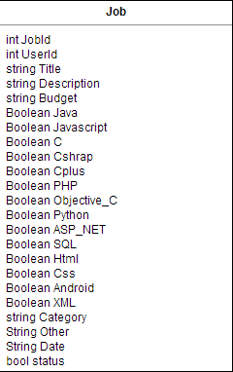

**Property**

|  |  |  |  |
| --- | --- | --- | --- |
| **ID** | **Name** | **Description** | **Remark** |
| 1 | JobId | Automate Value to set id of job | Type: int |
| 2 | UserId | Automate Value to set id of user | Type: int |
| 3 | Title | Value set for retrieve job Title | Type: string |
| 4 | Description | Value set for retrieve job Description | Type: string |
| 5 | Budget | Value set for retrieve budget of job | Type: Budget |
| 6 | Java | Value set for retrieve software skill job in type Java | Type: Boolean |
| 7 | Javascript | Value set for retrieve software skill job in type Javascript | Type: Boolean |
| 8 | C | Value set for retrieve software skill job in type C | Type: Boolean |
| 9 | Csharp | Value set for retrieve software skill job in type Csharp | Type: Boolean |
| 10 | Cplus | Value set for retrieve software skill job in type Cplus | Type: Boolean |
| 11 | PHP | Value set for retrieve software skill job in type PHP | Type: Boolean |
| 12 | Objective_C | Value set for retrieve software skill job in type Objective_C | Type: Boolean |
| 13 | Python | Value set for retrieve software skill job in type Python | Type: Boolean |
| 14 | ASP_NET | Value set for retrieve software skill job in type ASP_NET | Type: Boolean |
| 15 | SQL | Value set for retrieve software skill job in type SQL | Type: Boolean |
| 16 | Html | Value set for retrieve software skill job in type Html | Type: Boolean |
| 17 | CSS | Value set for retrieve software skill job in type CSS | Type: Boolean |
| 18 | Android | Value set for retrieve software skill job in type Android | Type: Boolean |
| 19 | XML | Value set for retrieve software skill job in type XML | Type: Boolean |
| 20 | Category | Value set for retrieve software role type | Type: string |
| 21 | Other | Value set for retrieve other skill | Type: string |
| 22 | Date | Value set for show date of job | Type: string |
| 23 | Status | Value set status of job | Type: Boolean |

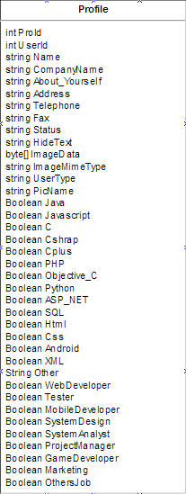

**Property**

|  |  |  |  |
| --- | --- | --- | --- |
| **ID** | **Name** | **Description** | **Remark** |
| 1 | ProId | Automate Value to set id of Profile | Type: int |
| 2 | UserId | Automate Value to set id of UserId | Type: int |
| 3 | Name | Value set for retrieve Name of User | Type: string |
| 4 | CompanyName | Value set for retrieve CompanyName of User | Type: string |
| 5 | About_Yourself | Value set for retrieve About_Yourself of User | Type: string |
| 6 | Address | Value set for retrieve Address of User | Type: string |
| 7 | Telephone | Value set for retrieve Telephone of User | Type: string |
| 8 | Fax | Value set for retrieve Fax of User | Type: string |
| 9 | Status | Value set for retrieve Status of User | Type: string |
| 10 | HideText | Value set for HideText from User | Type: string |
| 11 | ImageData | Value set for retrieve ImageData of User | Type: byte[] |
| 12 | ImageMimeType | Value set for retrieve ImageMimeType of User | Type: string |
| 13 | UserType | Value set for retrieve UserType of User | Type: string |
| 14 | PicName | Value set for retrieve PicName of User | Type: string |
| 15 | Java | Value set for retrieve software skill job in type Java | Type: Boolean |
| 16 | Javascript | Value set for retrieve software skill job in type Javascript | Type: Boolean |
| 17 | C | Value set for retrieve software skill job in type C | Type: Boolean |
| 18 | Csharp | Value set for retrieve software skill job in type Csharp | Type: Boolean |
| 19 | Cplus | Value set for retrieve software skill job in type Cplus | Type: Boolean |
| 20 | PHP | Value set for retrieve software skill job in type PHP | Type: Boolean |
| 21 | Objective_C | Value set for retrieve software skill job in type Objective_C | Type: Boolean |
| 22 | Python | Value set for retrieve software skill job in type Python | Type: Boolean |
| 23 | ASP_NET | Value set for retrieve software skill job in type ASP_NET | Type: Boolean |
| 24 | SQL | Value set for retrieve software skill job in type SQL | Type: Boolean |
| 25 | Html | Value set for retrieve software skill job in type Html | Type: Boolean |
| 26 | CSS | Value set for retrieve software skill job in type CSS | Type: Boolean |
| 27 | Android | Value set for retrieve software skill job in type Android | Type: Boolean |
| 28 | XML | Value set for retrieve software skill job in type XML | Type: Boolean |
| 29 | Other | Value set for retrieve other skill | Type: string |
| 30 | WebDeveloper | Value set for retrieve software role job in type WebDeveloper | Type: Boolean |
| 31 | Tester | Value set for retrieve software role job in Tester | Type: Boolean |
| 32 | MobileDeveloper | Value set for retrieve software role job in MobileDeveloper | Type: Boolean |
| 33 | SystemDesign | Value set for retrieve software role job in SystemDesign | Type: Boolean |
| 34 | SystemAnalyst | Value set for retrieve software role job in SystemAnalyst | Type: Boolean |
| 35 | ProjectManager | Value set for retrieve software role job in ProjectManager | Type: Boolean |
| 36 | GameDeveloper | Value set for retrieve software role job in GameDeveloper | Type: Boolean |
| 37 | Marketing | Value set for retrieve software role job in Marketing | Type: Boolean |
| 38 | OthersJob | Value set for retrieve software role job in type OthersJob | Type: Boolean |

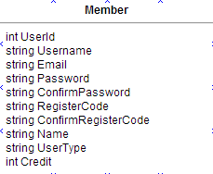

**Property**

|  |  |  |  |
| --- | --- | --- | --- |
| **ID** | **Name** | **Description** | **Remark** |
| 1 | UserId | Automate Value to set id of User | Type: int |
| 2 | Username | Value to retrive and set Username from User | Type: string |
| 3 | Email | Value to retrive and set Email from User | Type: string |
| 4 | Password | Value to retrive and set Password from User | Type: string |
| 5 | ConfirmPassword | Value to retrive ConfirmPassword from User | Type: string |
| 6 | RegisterCode | Value set for RegisterCode to User | Type: string |
| 7 | ConfirmRegisterCode | Value retrieve ConfirmRegisterCode from User | Type: string |
| 8 | UserType | Value set Type of User | Type: string |
| 9 | Status | Value set status of User | Type: string |

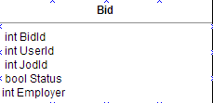

**Property**

|  |  |  |  |
| --- | --- | --- | --- |
| **ID** | **Name** | **Description** | **Remark** |
| 1 | BidId | Automate Value to set id of Bid | Type: int |
| 2 | UserId | Automate Value to set id of User | Type: int |
| 3 | JobId | Automate Value to set id of Job | Type: int |
| 4 | Status | Value to check status of bid | Type: bool |

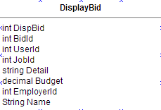

**Property**

|  |  |  |  |
| --- | --- | --- | --- |
| **ID** | **Name** | **Description** | **Remark** |
| 1 | DispBid | Automate Value to set id of Bidlist | Type: int |
| 2 | BidId | Automate Value to set id of Bid | Type: int |
| 3 | UserId | Automate Value to set id of User | Type: int |
| 4 | JobId | Automate Value to set id of Job | Type: int |
| 5 | Detail | Value set to retrieve detail for Bid | Type: string |
| 6 | Budget | Value set to retrieve Budget for Bid | Type: Budget |

## 3.3 Sequence Diagram

Sequence diagram separated into two user in 3 user that is **service request customer**, **freelancer supply** and **Guest** Sequence Diagram will separate following group of the user of WebApplication ID of sequence diagram will follow this

If Sequence diagram related with ***Service request customer*** user-type, Sequence diagram will be format like this - E – SQD – [Number of Sequence diagram]

(**EX** E-SQD-01: Register for **service request customer**)

If Sequence diagram related with ***freelancer supply*** user-type, Sequence diagram will be format like this - F – SQD – [Number of Sequence diagram]

(**EX** F-SQD-01: Register for **Freelancer supply**)

### *Service request customer*

E-SQD-01: Register for **service request customer**

E-SQD-02: Confirm Register for **service request customer**



E-SQD-03: Login for **service request customer**

E-SQD-04: Add&Edit Profile for **service request customer**



E-SQD-05: Logout for **service request customer**



E-SQD-06:Request password for **service request customer**

E-SQD-07: Post Project for **service request customer**



E-SQD-08: See freelancer for **service request customer**



E-SQD-09: **service request customer** can view project list in system



E-SQD-10: **service request customer** can view list of bidding below project



E-SQD-11: **service request customer** can request freelancer in list

### *Freelancer supply*

F-SQD-01: Register for **freelance supply**

F-SQD-02: Confirm Register for **freelance supply**



F-SQD-03: Login for **freelance supply**



F-SQD-04: Add&Edit Profile for **freelance supply**



F-SQD-05: Logout for **service request customer**

F-SQD-06: Request password for **supply freelance**

# Chapter Four | Data Architecture

## 4.1 ER Diagram

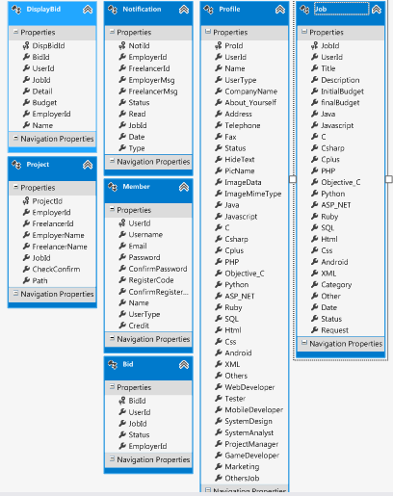

## 4.2 DB Design

DB 01 - Member

|  |  |  |
| --- | --- | --- |
| **Field** | **Type** | **AllowNull** |
| UserId | int |  |
| Username | nchar(20) |  |
| Email | nchar(50) |  |
| Password | nchar(20) |  |
| ConfirmPassword | nchar(20) |  |
| RegisterCode | nchar(20) |  |
| ConfirmRegisterCode | nchar(20) |  |
| Name | nchar(20) |  |
| UserType | nchar(20) |  |
| Credit | int |  |

DB 02 - Profile

|  |  |  |
| --- | --- | --- |
| **Field** | **Type** | **AllowNull** |
| ProId | int |  |
| UserId | int |  |
| Name | nchar(50) |  |
| UserType | nchar(20) |  |
| CompanyName | nchar(30) |  |
| About_Yourself | nchar(200) |  |
| Address | nchar(300) |  |
| Telephone | nchar(10) |  |
| Fax | nchar(10) |  |
| Status | nchar(30) |  |
| HideText | nchar(10) |  |
| PicName | nchar(50) |  |
| ImageData | varbinary(max) |  |
| ImageMimeType | varchar(50) |  |
| Java | bit |  |
| JavaScript | bit |  |
| C | bit |  |
| CSharp | bit |  |
| Cplus | bit |  |
| PHP | bit |  |
| Objecttive-C | bit |  |
| Python | bit |  |
| ASP.NET | bit |  |
| Ruby | bit |  |
| SQL | bit |  |
| Android | bit |  |
| XML | bit |  |
| Others | nchar(150) |  |
| WebDeveloper | bit |  |
| Tester | bit |  |
| MoblieDeveloper | bit |  |
| SystemDesign | bit |  |
| SystemAnalysist | bit |  |
| ProjectManager | bit |  |
| GameDeveloper | bit |  |
| Marketing | bit |  |
| OtherJob | bit |  |

DB 03 - Job

|  |  |  |
| --- | --- | --- |
| **Field** | **Type** | **AllowNull** |
| JobId | int |  |
| UserId | int |  |
| Title | nchar(30) |  |
| Descliption | nchar(800) |  |
| IntitialBudget | decimal(16,2) |  |
| finalBudget | decimal(16,2) |  |
| Java | bit |  |
| JavaScript | bit |  |
| C | bit |  |
| CSharp | bit |  |
| Cplus | bit |  |
| PHP | bit |  |
| Objecttive-C | bit |  |
| Python | bit |  |
| ASP.NET | bit |  |
| Ruby | bit |  |
| SQL | bit |  |
| Android | bit |  |
| XML | bit |  |
| Category | nchar(25) |  |
| Other | nchar(100) |  |
| Date | nchar(300) |  |
| Status | bit |  |

DB 04 - Bid

|  |  |  |
| --- | --- | --- |
| **Field** | **Type** | **AllowNull** |
| BidId | int |  |
| EmployerId | int |  |
| UserId | int |  |
| JobId | int |  |
| Status | bit |  |

DB 05 - DisplayBid

|  |  |  |
| --- | --- | --- |
| **Field** | **Type** | **AllowNull** |
| DispBidId | int |  |
| EmployerId | int |  |
| BidId | int |  |
| UserId | int |  |
| JobId | int |  |
| Detail | nchar(50) |  |
| Budget | decimal(16,2) |  |
| Name | nchar(50) |  |

DB 06 - Notification

|  |  |  |
| --- | --- | --- |
| **Field** | **Type** | **AllowNull** |
| NotiId | int |  |
| JobId | int |  |
| EmployerId | int |  |
| FreelancerId | int |  |
| EmployerMsg | nchar(100) |  |
| FreelancerMsg | nchar(50) |  |
| Status | bit |  |
| Read | bit |  |
| Date | nchar(20) |  |
| Type | nchar(10) |  |

# Chapter Five | User Interface Design

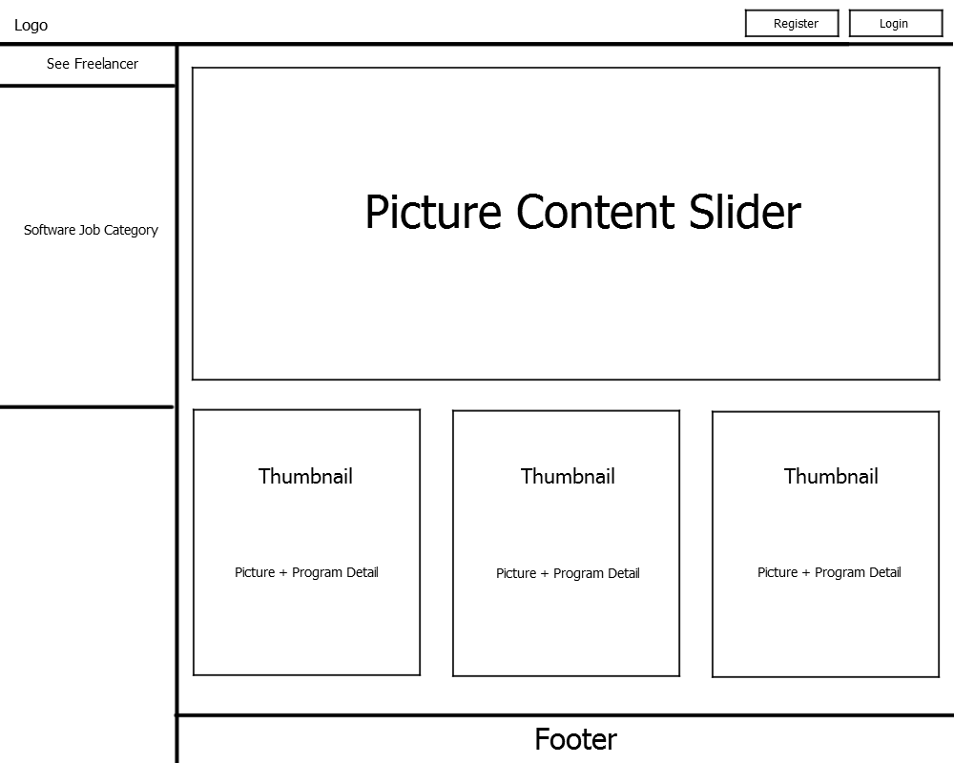UID 01 – HomePage

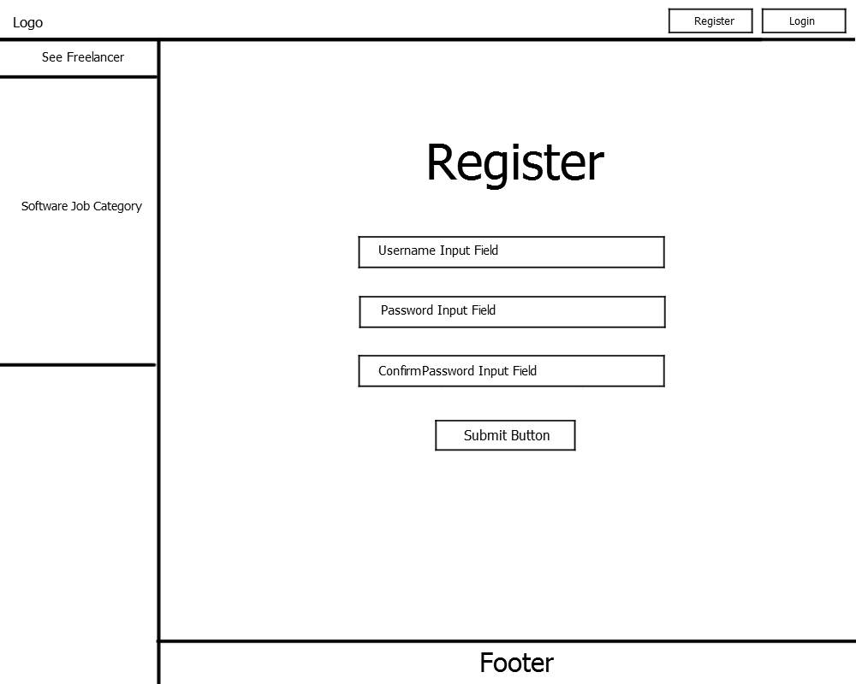UID 02 - Register

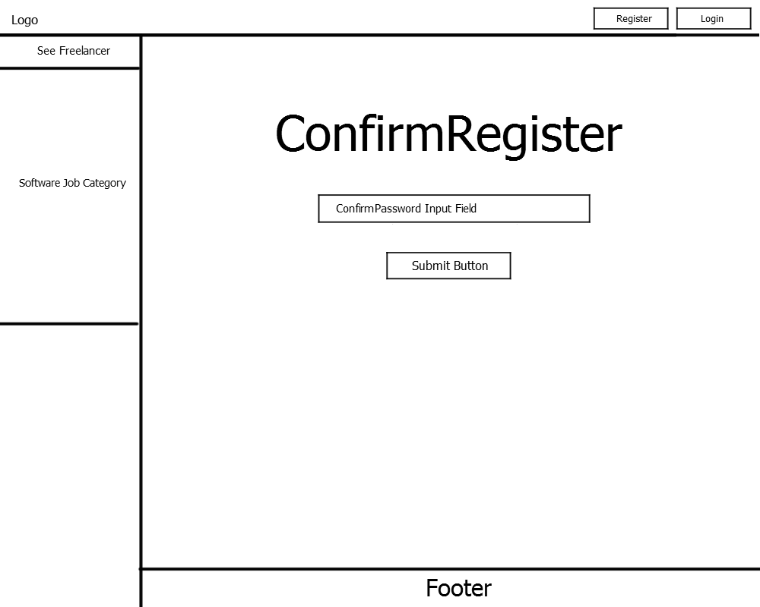UID 03 – ConfirmRegister

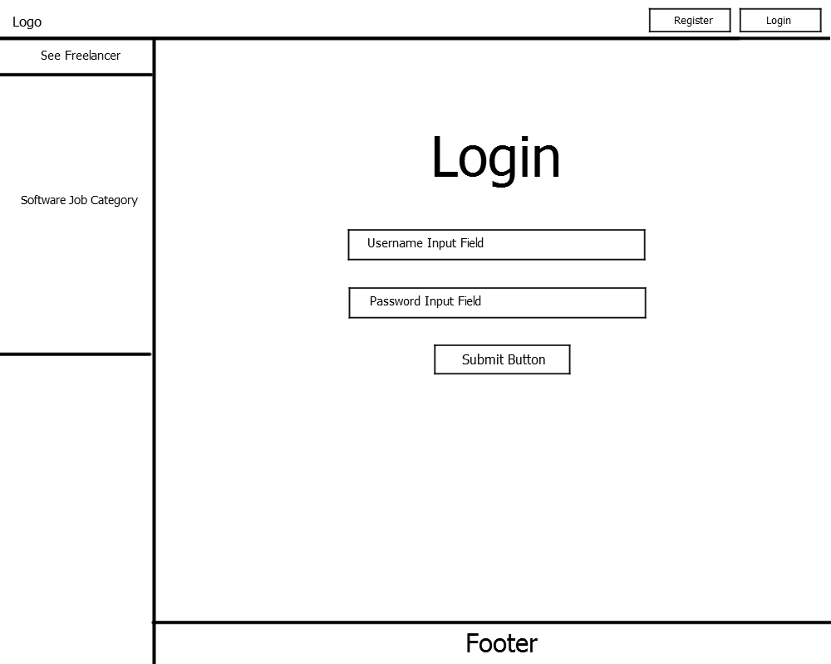UID 04 – Login

Are you Forget Password?

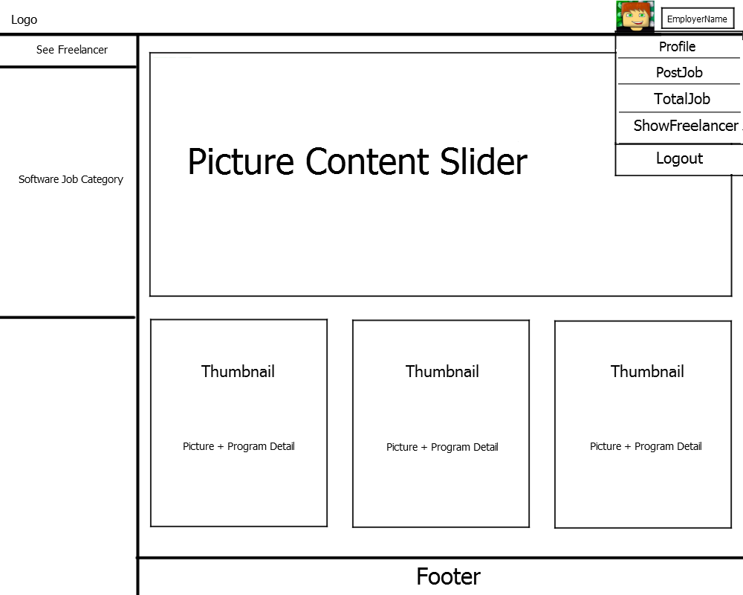UID 05 – EmployerMainPage

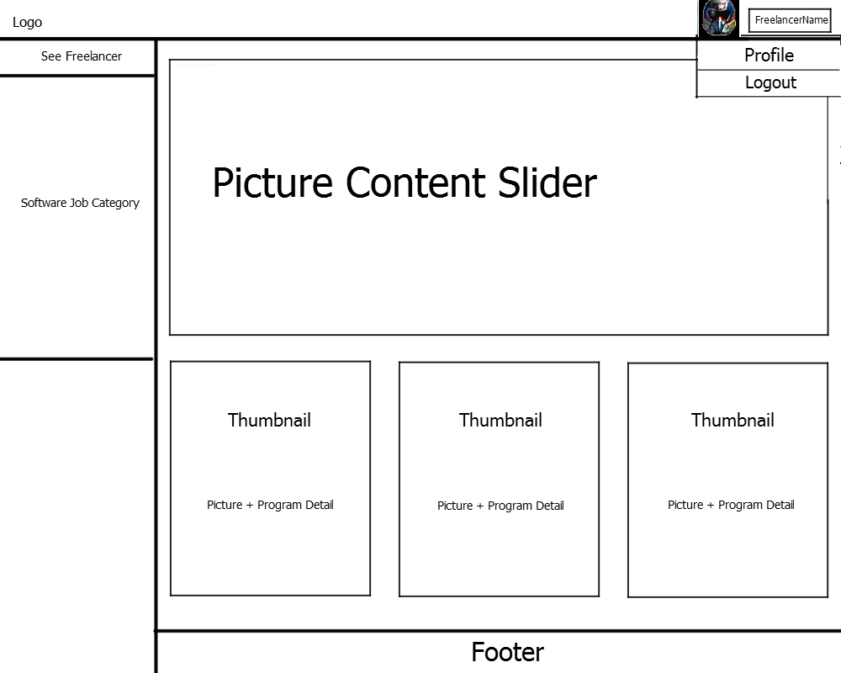UID 06 – FreelancerMainPage

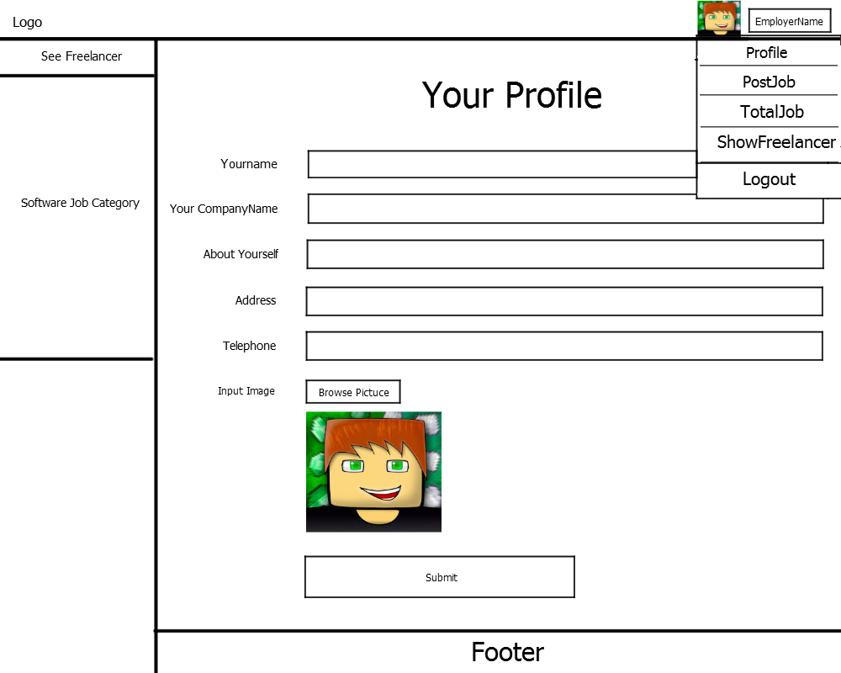UID 07 – EmployerProfile

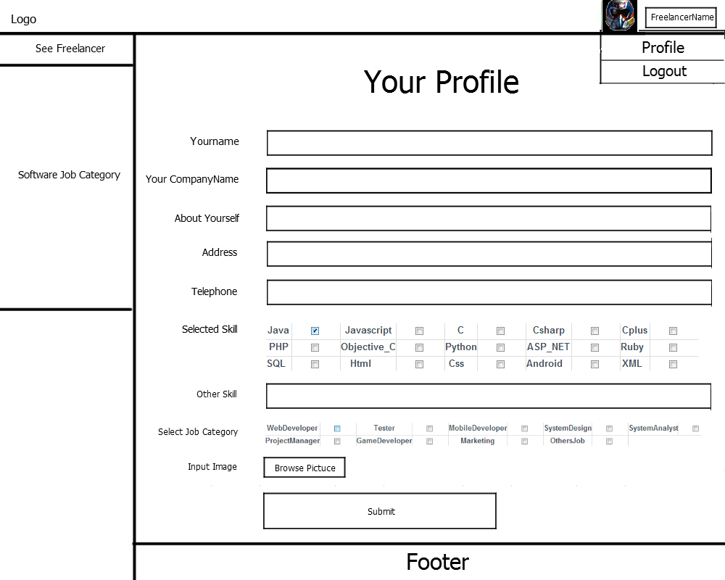UID 08 – FreelancerProfile

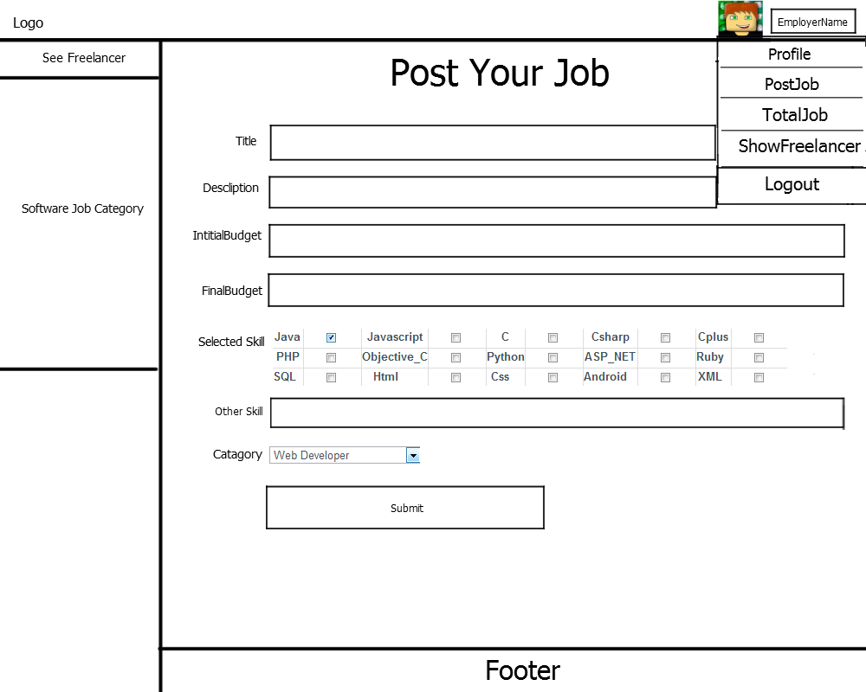UID 09 – PostJob

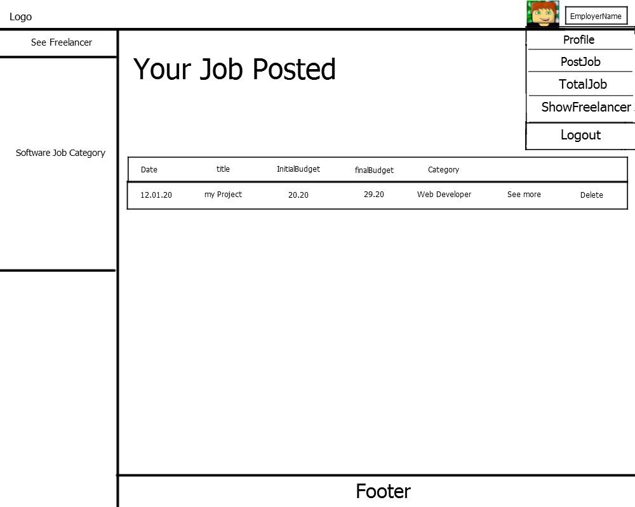UID 10 – TotalJob

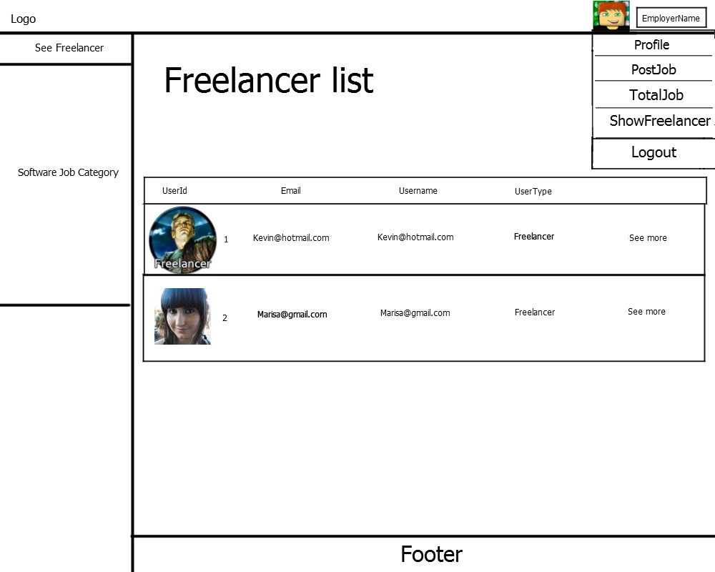UID 11 – Show Freelancer list

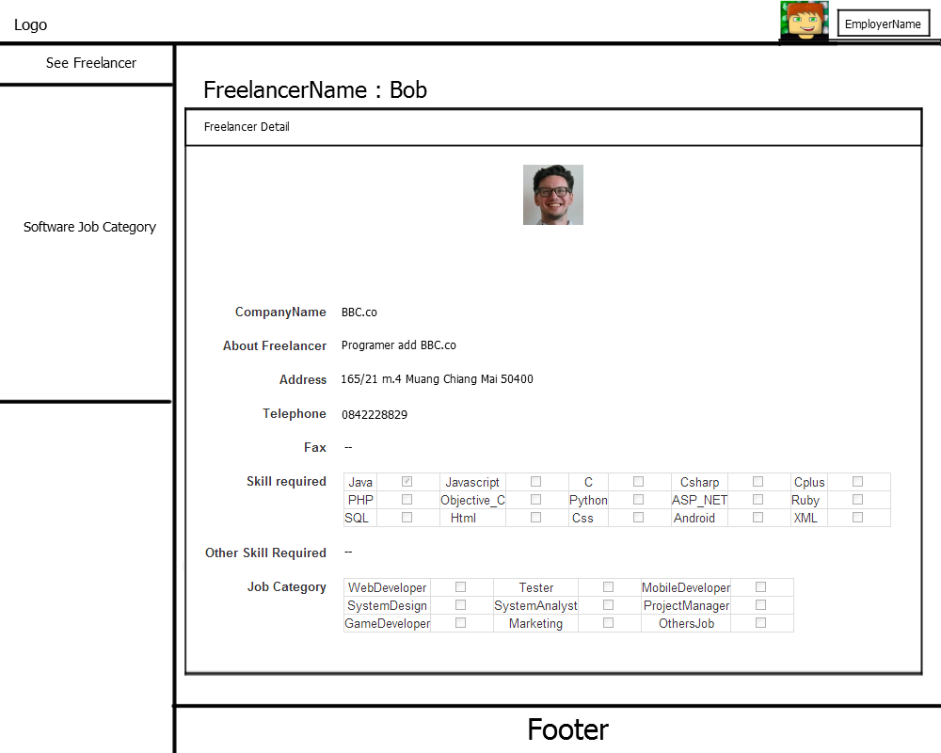UID 12 – Show Freelancer Detail

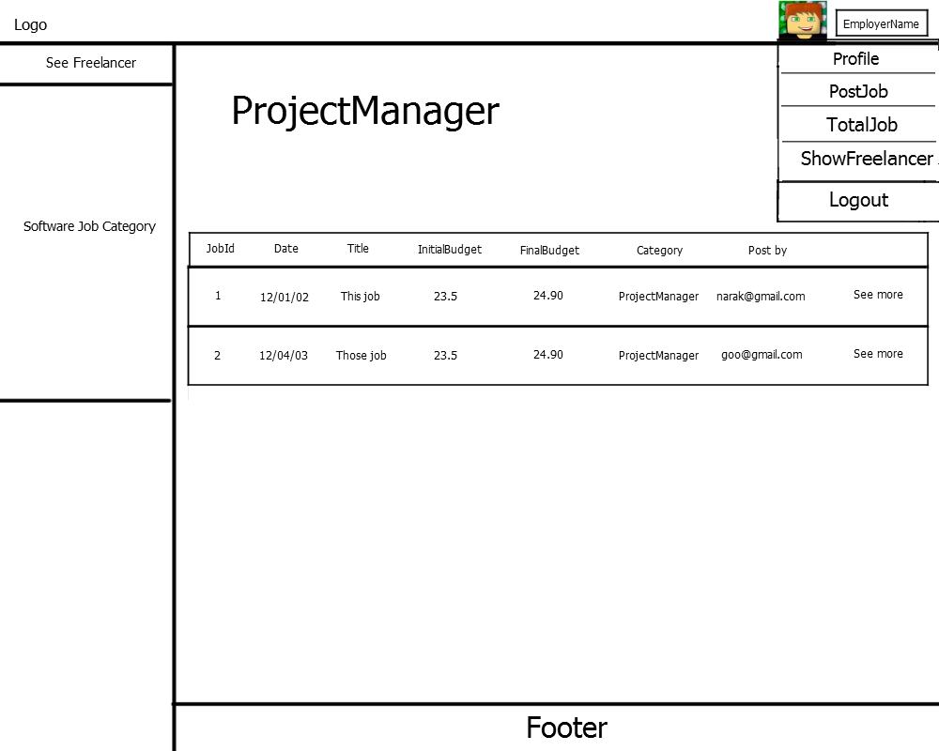UID 13 – Show Job list

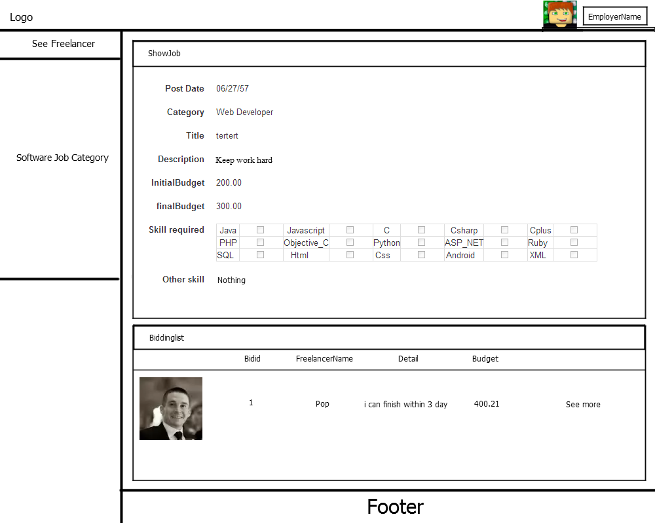UID 14 – Show Job Detail

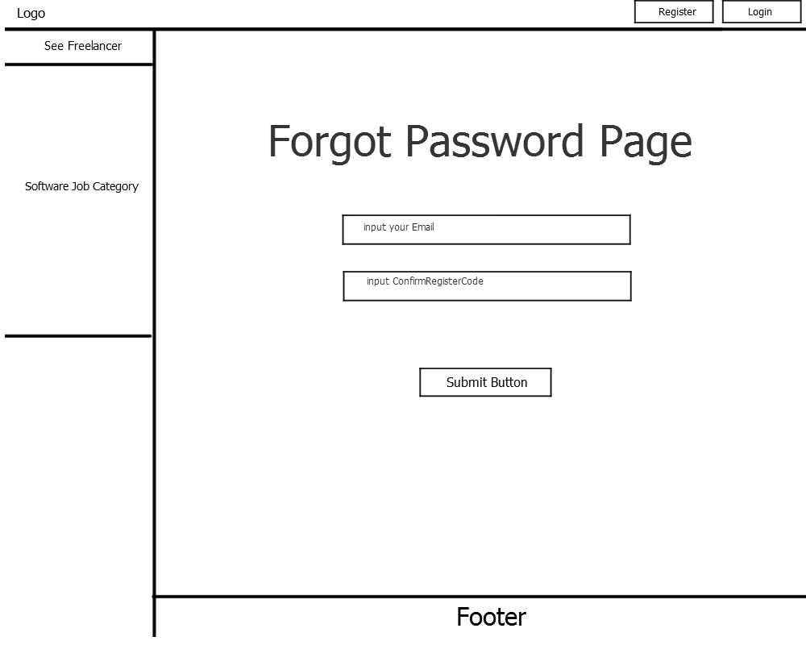UID 15 – Forgot password